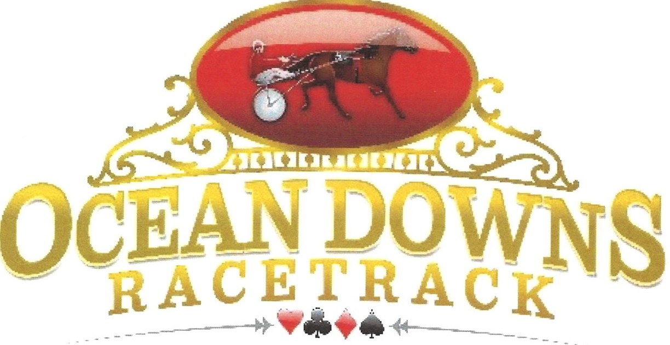

Welcome to the 2020 Ocean Downs Racing Season!
We are pleased to announce that the 2020 season will start July 6th.
This year we are faced with the COVID 19 pandemic. With this packet we are distributing the CDC’s recommendations for all to follow. We will be following up with more recommendations set by both the MRC and Ocean Downs in the near future. Please remember, following the recommendations is for everyone’s safety and is what will keep us racing.
This year we will still be using direct deposit for all horsemen. There will be ONE options for payments: DIRECT DEPOSIT. If you have a direct deposit form on file from last year, there is no need to fill another request out. The information sheet and W-9 still need to be completed and returned.

Please review the enclosed packet and complete all information on all forms. These must be returned via email to wendy.burton@oceandowns.com, dropped off at the Racing Administration office or faxed to 410-629-6678 Attention: Wendy Burton. For direct deposit, please mail or drop off original forms with a voided check.
This information is now required to ensure timely payments for all Horsemen. Paperwork must be received in the Horsemen's Bookkeeper office by 12 noon on Tuesday to be included in that week's payments. Weekly payments will be made to owners, trainers and drivers.
If you should have further questions, please contact Wendy Burton at 410.641.0600 ext. 3136.
Thank you very much for your cooperation and participating in this year’s live meet.

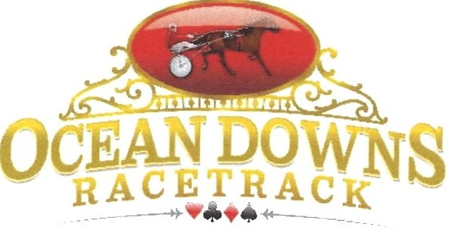

PLEASE PRINT CLEARLY

Individual Name:- - - - - - - - - - - - - - - - - - - - - - -

Social Security Number:_ _ _ _ _ _ _ _ _ _ _ _ _ _ _ _ _ _ _ _ _

OR
Partnership: _

Primary Social Security Number:

OR
Corporation:_ _ _ _ _ _ _ _ _ _ _ _ _ _ _ _ _ _ _ _ _ _ _ _

Federal ID Number:- - - - - - - - - - - - - - - - - - - - - -

Role: Owner
Trainer
Driver

Street Address:- - - - - - - - - - - - - - - - - - - - - - - -

City:_ _ _ _ _ _ _ _ _ _ _ _
State:---- Zip Code: _

Contact Telephone Number:_ _ _ _ _ _ _ _ _ _ _ _ _ _ _ _ _ _ _

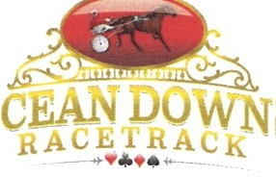

Direct Deposit Authorization Agreement

Authorization Agreement

I hereby authorize Ocean Downs to initiate automatic deposits to my account at the financial institution named below.

Further, I agree not to hold Ocean Downs responsible for any delay or loss of funds due to incorrect or incomplete information supplied by me or by my financial institution or due to an error on the part of my financial institution in depositing funds to my account.

This agreement will remain in effect until Ocean Downs receives a written notice of cancellation from me or my financial institution, or until I submit a new direct deposit form to the Horsemen's Bookkeeper.

A separate Direct Deposit Authorization Agreement must be completed for every partnership. Please attach a voided check for verification of your pay distribution requests.

Account Information

Name of Financial Institution:

Routing Number:

Checking

Savings

Account Number:
- - - - - - - - - - - - - - - - - □ □

Personal Information

Name: Address: Phone: Email:

Signature

Authorized Signature (Primary): - - - - - - - - - - - - - - - - -

Date:

Authorized Signature (Joint): Date:

Authorized Signature (Joint):
- - - - - - - - - - - - - - - - -
Date:

Authorized Signature (Joint): Date: Please attach a voided check and return this form to the Horsemen's Bookkeeper.

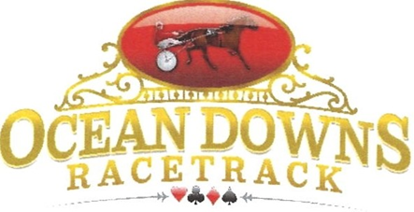

OWNERS ONLY
PLEASE COMPLETE THE FOLLOWING INFORMATION IF YOUR HORSE IS ELIGIBLE TO RECEIVE MARYLAND BONUS MONEY.
The definitions of a MD owned and/or bred are:

  - MD bred mare fully owned by a MD resident at the time of conception
  - MD owned-de fined as owner at the time of declaration while residing in MD
  - MD sired by a registered MD stallion
Name of Horse: Name of Owner: USTA MEMBER#-----

MRC LICENSE# _

I certify that the above named horse complies with the standards within and in accordance with the bonus agreement in place between Ocean Downs LLC and the Cloverleaf Standardbred Owners Association.
***Please note: All decisions on horses' bonus eligibility will be final and will be that of CSOA and ODLLC. Any attempt to circumvent the bonus eligibility of horse owner ship will result in loss of bonus payment and a loss of racing privileges.

Signature:_ _ _ _ _ _ _ _ _ _ _ _ Date:-------

